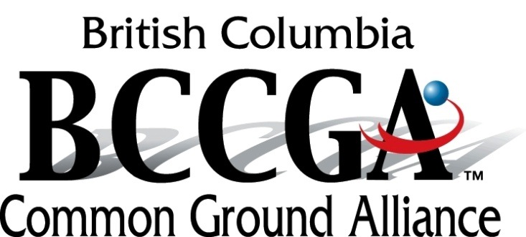

Annual General Meeting
Wednesday, April 26, 2017 at 9:30 am to 3:30 pm
BC Hydro – Presentation Centre
333 Dunsmuir Street, Vancouver

AGENDA

9:30 Coffee and networking
10:00 Welcome
10:05 Michelle Petrusevich, FortisBC – Communications Committee Strategy
10:35 Abigail Fulton, Construction Foundation – Learn Safe
11:20 Garry Wilson – WorkSafeBC – High Risk Strategy
12:00 LUNCH (will be provided)
12:45 Call meeting to order
12:45 Roll Call – Establish Quorum, Introductions and Process Overview
12:50 Approval of Minutes for AGM of 2016
12:55 Business arising from Minutes
1:00 President’s Welcome Remarks
1:10 Executive Director’s Report
1:20 Treasurer’s Report
1:25 Waive the Appointment of Auditors for Fiscal 2017
1:30 Election of Directors
2:15 Other Business
2:20 Date for next year’s AGM
2:25 Adjournment

2:30 to 3:15 pm Board Meeting (Ratification of Officer positions)

** Please note that members must have paid membership dues (2017) and be in attendance to be eligible to vote and/or stand for election and/or retain Board seat.

Election of Directors

Stakeholder Groups for Election ~
Stakeholder Group | Representative
Equipment Manufacturing and Suppliers | EECOL (Brian Kidwell)
Gas / Oil Distribution | FortisBC (Michelle Petrusevich / Ian Turnbull)
Home Builders | Vacant
Municipal and Public Works | Vacant
Railway | Vacant
Transmission Pipelines | TransCanada (Patricia Poulton)  Kinder Morgan Canada (Rob Hadden)  Spectra Energy (Christine Balash)
Members at Large 1(3 position) | Telcom (Bob Mizon)
Road Builders | BC Roadbuilders and Heavy Construction Association (Kelly Scott)
Electrical Transmission / Distribution | BC Hydro (Raj Sharma)
Safety Organizations | BC Construction Safety Association (Mike McKenna / Urvi Ramsoondar)
Landscaping /Fencing | BC Landscapers Association (Brian Ramor)

Stakeholder Groups with One Year Remaining
Stakeholder Group | Current Representative
Engineering and Land Surveying | Association of BC Land Surveyors (Scott Netherton)
Excavator | BC Construction Association (Chris Atchison)  Flatiron Construction (Keith Mitchell)
One Call Centre | BC One Call (Gary Metz/Darlene Dyson)
Regulators | WorkSafeBC (Don Schouten)  National Energy Board (Shannon Neufeld)  BC Oil & Gas Commission (Lance Ollenberger)  BC Safety Authority (Frank Do)
Telecommunications | Bell (Mitch Williams)  Telus (Jordan West)
Locators | Geoscan (Mike Grunde / Joseph Salazar)  Western Leakage (Rob Andrews)  Quadra Utility Locating (Jesse Powers)
Insurance | Independent Contractors and Builders Association (Sabine Just)
Members at Large 2 (3 positions) | Kiewit Infrastructure Co. (Adam Phipps)
Members at Large 3 (3 positions) | Debbie Clyne (Independent)
Emergency Services | Kwantlen Polytechnic University (Ron Enns)

